Northwest Village Bulletin
NWVillagecda.com


June 2012

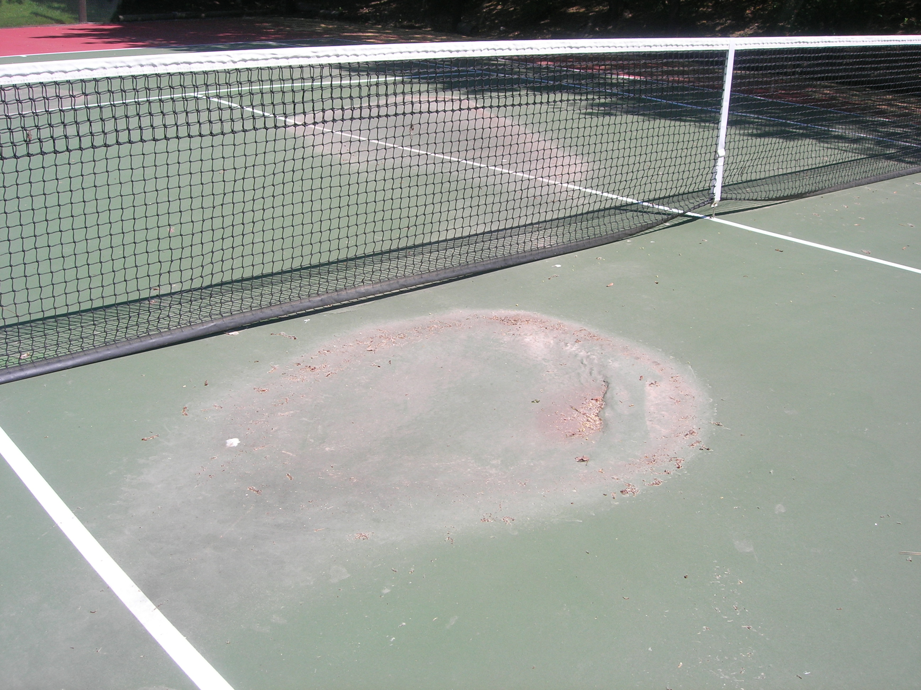
Summer Tips
- For the security of all our residents, please be sure you secure the pedestrian gates behind you when you leave or enter NW Village.
- As a reminder, ALL pets must be kept inside and be on a leash when outside. Please be sure to pick up waste deposited by your dog.
- The pool and hot tub are now open for use. Please follow the pool rules in order to be safe this summer.
- Exterior maintenance request forms are available in each of the garbage sheds.
- Did you know? An easy shortcut for your guests to use to contact you at the call box : simply enter your unit number, then press "Call."
- Storage other than patio furniture is not permitted on decks or porches.
- Additional parking spaces can be rented on a monthly basis. Please see Chris Baker in Unit #44 for details.

Pool Pizza Party
Wednesday, June 27th
at 6:00 p.m.

Annual Meeting
June 27th at 7:00 p.m.
One owner from each unit is asked to attend or submit an executed proxy in their absence.

Depressions on the Surface of the Tennis Court
Greetings from the Board President!

Welcome to the summer season at Northwest Village! We hope you enjoy our beautiful grounds as you walk around the Village. Our landscape and maintenance contractor, Dan Durr, has been hard at work to keep the landscaping looking its best! Let him know his efforts are appreciated.
The pool and hot tub are now open for your use and we hope you will take advantage of these amenities while being respectful of the facilities and other residents. It is the responsibility of all who use the clubhouse and pool area to clean up after themselves including taking pool toys back to respective condos when the day is over.
We hope to see all of our residents at the annual pizza party prior to the start of the Annual Homeowners meeting on Wednesday, June 27th. This is a great opportunity to meet your neighbors and Board members. See you poolside!
Your Board is here to serve the best interests of the whole community. If you have questions, concerns or comments, please contact one of us to share your thoughts. On behalf of the Board of Directors,
Annie Mote
2011-2012 Board President

Northwest Village Owners Association – NWVillagecda.com
Lou and Sue Fleming, Association Managers – 208-667-1144

News around the Village

Over the past several of months we’ve been assessing some significant new problems with our tennis court. Depressions have occurred in several locations around the court that make the court no longer safe for play. We've consulted with geo-technical engineers about the problem, and the general consensus is that significant amounts of organic material are likely buried beneath the court, left over from when this site was used as part of a saw mill operation. Over time, those materials have slowly been de-composing, resulting in the failure of the base below the court. The Board is currently assessing how best to respond to this potentially very expensive problem.

Major projects around the complex for this year include the following:
  - We will begin the lengthy process of re-painting our buildings this summer. We are planning to start with the south sides of Buildings 5, 6, 7 and 8 because they are the most deteriorated and in need of paint to preserve the wood siding from further damage. Painting the entire complex will take years to complete.
  - We will seal cracks in our asphalt drive to prevent further damage and erosion.
  - We will plant some additional new shrubbery around the complex to replace old shrubs and dead trees that were removed over the past several years.
  - We recently installed metal caps on the tops of all the pool fence posts to help prolong their life.
  - Fortunately, all our trees appear to have made it through the past winter, and for the first time in a number of years we won't have to cut down any dead or dying trees this summer.

Additional Information for Homeowners:
  - One of the vegetable garden plots behind the clubhouse is available for use by any resident who would like to use it; please see Joy Fitzpatrick in Unit #14 for details.
  - The covered barbeque adjacent to the pool is available for use by residents throughout the summer!
  - There are currently two units for sale in the complex: Unit #27 and Unit #49.

We would like to remind all homeowners that sub-section 11.6.1 of the Declaration requires that any improvements to your unit be reported to the Association. If you have undertaken any remodeling to your unit, or made other significant improvements totaling $1,000 or more, including new appliances, please report those improvements and their approximate value to the Association's co-managers in writing.

IMPORTANT NOTICE: the karaoke machine has been missing from the clubhouse since last summer. If you or someone your know borrowed it, please contact the managers about returning it. It is needed as a sound system for the Annual Meeting. If it is not returned, we will have to conclude that it was stolen.

The City of Coeur d' Alene has informed us that Lincoln Way will be repaved this summer, probably sometime in July. On the day when that occurs, residents may notice some drop in water pressure, as one of two water sources to the Village will be temporarily turned off while the asphalt repaving is occurring. On that day, the Lincoln Way entrance to the Village will be temporarily closed, so residents will need to use the Hubbard St. entrance.

The Board of Directors has adopted guidelines for the purchase, installation and maintenance of retractable patio awnings. If you are interested in purchasing a retractable awning to cover your deck, please see the Managers for a copy of the written guidelines.

Please help our new residents feel welcome:

- Dr. George Ullrich and Jami Sturgess-Ullrich in Unit #10
- Sheryl Green in Unit #11
- Kristin Odenthal returning to Unit #12 in late June
- Karen De Hoog in Unit #49
- Genevieve Rucker & Nicole Wolastin in Unit #50
- Debra & Kelly McGowan in Unit #51

Northwest Village Owners Association – NWVillagecda.com
Lou and Sue Fleming, Association C0-Managers – 208-667-1144

